1. Draw a flow chart to print "bitLabs" message 10 times.

Pseudocode:

Begin

Numeric I, String Bitlabs;

Accept I

I=1;

if(I<=10) {

Display "Bitlabs";

I=I++;

}

else {

stop

}

End

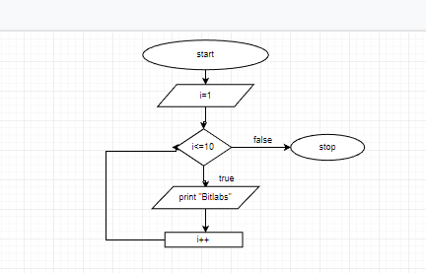

2) Draw a flow chart to print 1-10 numbers

Pseudocode:

Begin

Numeric I

Initialize I=1;

Accept I ;

If (I <= 10) {

Display I;

Increment I value;

}

Else{

}

end

3.Draw a flow chart to print 10-1 numbers

Pseudocode:

Begin

Numeric i;

Initialize i=10;

If(i<=10) {

Display I;

Decrement I value;

}

Else {

}

End

4.Draw a flow chart to print even numbers between 1-10 numbers

Pseudocode:

Begin

Numeric I;

Initialize I=1;

If(I<=10) {

If(I%2==0) {

Display I;

}

Else {

Increment I value;

}

}

5.Draw a flow chart to print odd numbers between 1-10 numbers

Pseudocode:

Begin

Numeric I;

Initialize I=1;

If(I<=10) {

If(I%2!=0) {

Display I;

}

Else {

Increment I value;

}

}

6.Draw a flow to accept start and stop values and print between values.

Pseudocode:

Begin

Numeric start, stop;

Accept start, stop values;

If(start<=stop) {

Display “start “;

Increment Start value;

}

Elseif (start>stop) {

Display “start”

Decrement Start value;

}

Else {

Display start and stop values;

}

End

